Talent Scouts

Talent Scouts

Activity Overview
Students analyze decisions made using limited vs. complete data to understand how to improve AI decision-making.
Learning Objective  Students understand that AI requires diverse data sources to make fair decisions. | Standards & Competencies  - 1b (Understand Mechanics)  - 2a (Identify/address biases)  - CCSS.MATH.PRACTICE.MP7 Look for and make use of structure
Materials  - Student Musician Datasets  - Class poster with Fair AI Guidelines | Preparation  - Print Musician dataset 1 and 2 for each student for comparison.  - Prepare sentence starters to support discussion.

Launch (1-2 minutes)
Slide | Exploration Guide
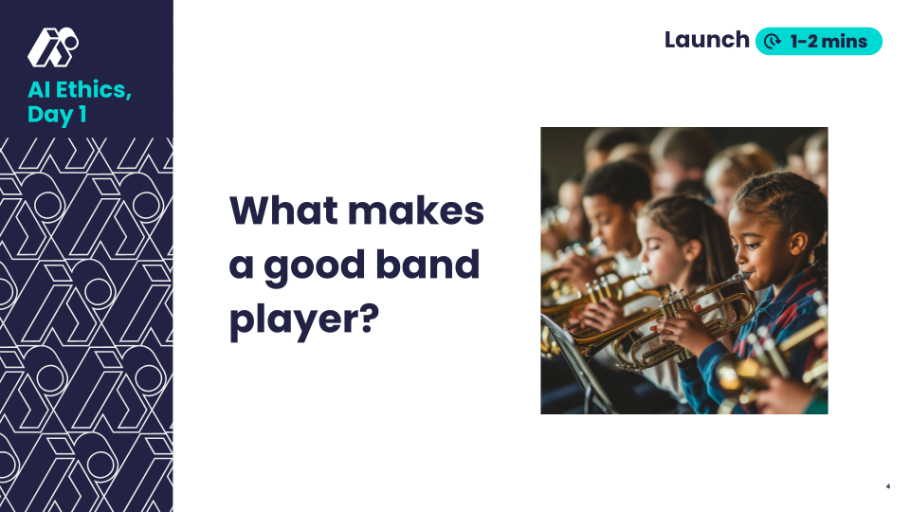 | Say: "Imagine you’re picking musicians to join your band. You want the best team, but you only get a little bit of information about them. Sometimes, AI makes decisions like this—it learns from the data it’s given, even if that data isn’t very helpful or complete.”  Ask: “What kind of information do you think would help you choose the best musicians?”  Look For:  - Someone who practices a lot, loves music, can read music, works well with others, etc
💡Teaching Tip: Pre-teach key vocabulary with image-supported word walls for terms like “AI”, “bias”, and “data.” Use a think-pair-share to give students processing time to think about the question before sharing aloud.

Play (12-15 minutes)
Slide | Exploration Guide
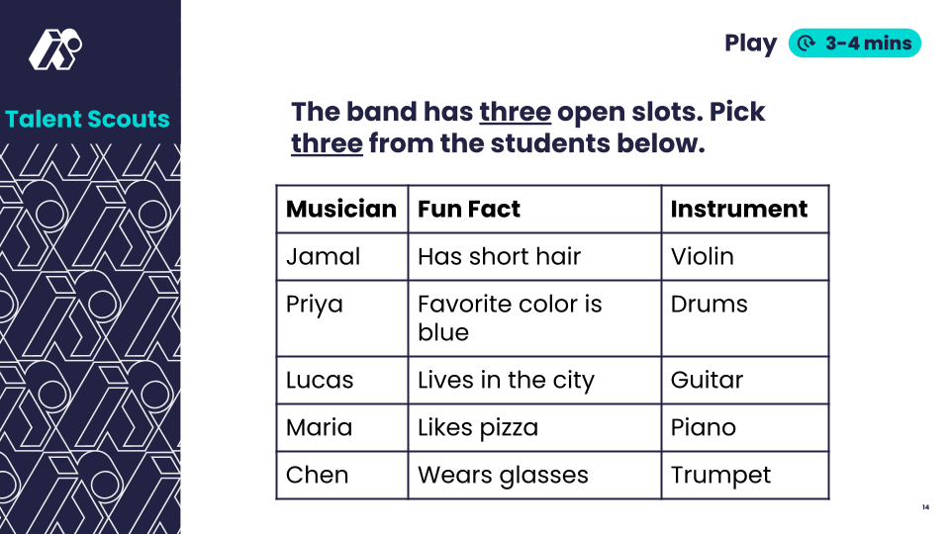 | Say: “Here are some musicians you can choose from. Look at each musician’s fun fact and instrument, and decide: Who would you pick for your band?”  In pairs or small groups, students circle or write down who they’d choose based on the info provided.  Students select two players from the options and write one sentence explaining each choice.  Look For:  - Students don’t feel confident in their decisions  - Students ask for more information
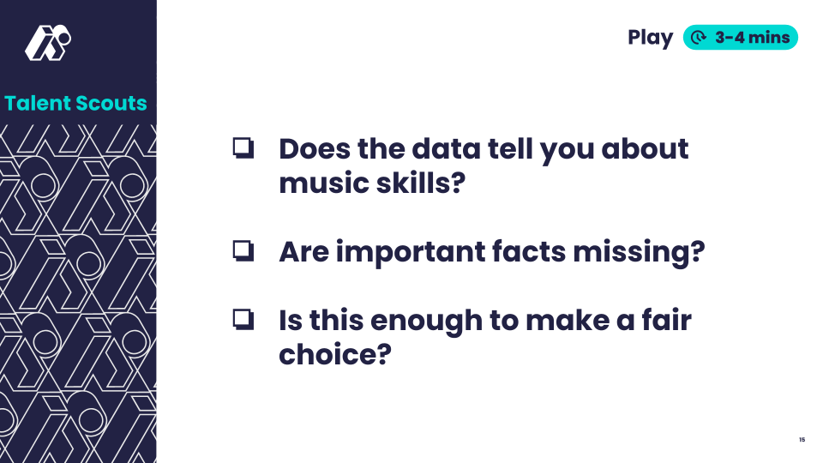 | Say: “Let’s check: Does the data actually tell you how good these musicians are? What’s missing?”  Ask: “What more do you wish you knew? How could this data lead to unfair or bad choices?”  Look For:  - “The data didn’t tell us anything about their music skills.”  - "We couldn’t tell how often they practice."  - “Selecting band members with this data could lead to unfair choices.”  Common Student Misconceptions:  - "More data automatically means better decisions."  - Response: "What if the extra data isn’t relevant? AI can’t make better choices with incomplete or irrelevant data."
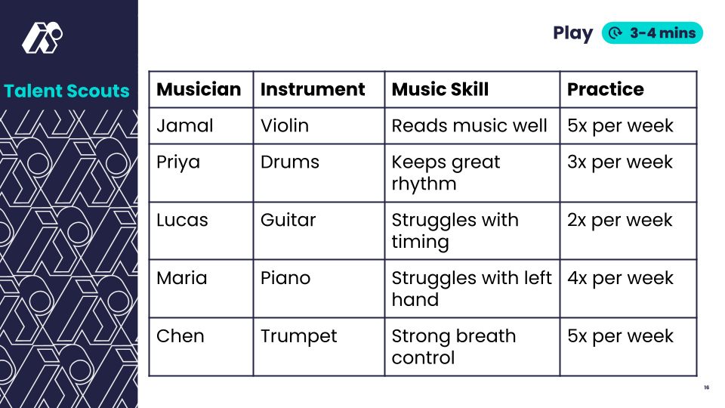 | Say: “Now you have a different dataset with more information. Let’s see if you want to change your choices.”  Students review data and decide whether they will revise their choices.  Look For:  - Students adjust their choices after seeing practice time and music skill.  - “Better data leads to fairer decisions.”
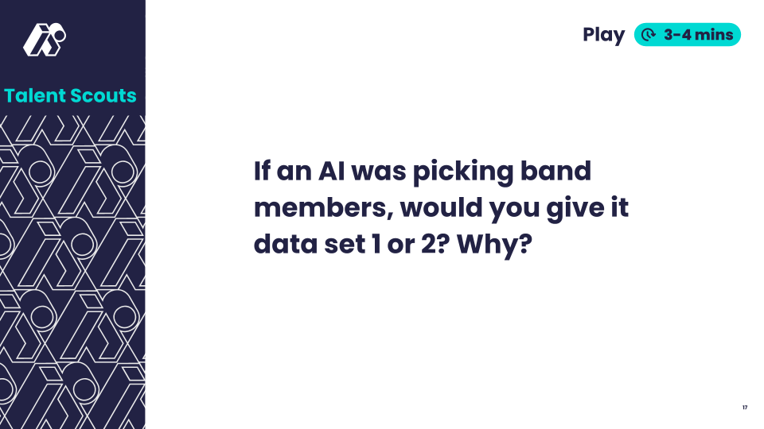 | Say: "If an AI was picking band members, which data set would you give it to make a decision? Why?"  Look For:  - Giving the AI the second data set would lead to more fair decisions because the data tells you more about their musical abilities.  - The band could miss out on good players if it only selected members based on the first data set  Common Student Misconceptions:  - "AI can figure things out even with limited data."  - Response: "AI only knows what it’s been trained on—better data leads to better outcomes."
💡Teaching Tip: Provide sentence frames:
- “I chose this musician because ____.”
- “AI only saw ____, but I wish I knew ____.”
- “I changed by choice because ____.”
- “The new data showed that ____.”
- “AI should use ______ so it can be fair because ______.”
Use a graphic organizer to compare “Known Data” vs. “Missing Data.”

Land (3-4 minutes)
Slide | Exploration Guide
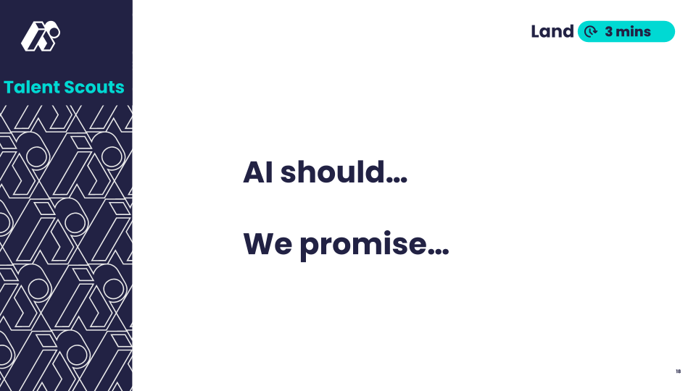 | Say: "Based on our learning today, let’s add a statement to our Fair AI Guidelines. What should always be true about fair AI? What could we do to make it more fair?"  Students discuss in pairs then share with class. Students propose wording for Fair AI guideline statement. Record statements with students OR show the next slide.  Look For:  - “AI should learn from lots of good data.”  - “We should check the data AI learns from.”  Common Student Misconceptions:  - "More data automatically means better decisions"  - Response: Ask, "What if the extra data isn't relevant or important?"
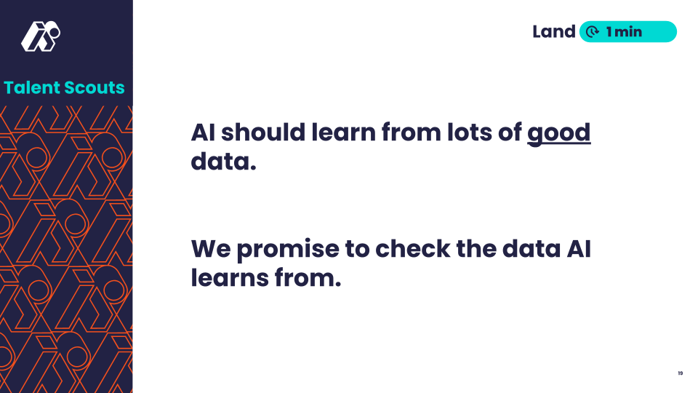 | Share this slide or the written version of the statements agreed upon by the class.  Say: "Here's one way we could phrase our learning. Does this capture our ideas, or do you prefer your wording?”
💡Teaching Tip: Use a closing sentence starter: “"AI should use ______ so it can be fair because ______.”

